US Census Tract –Other Sites

Background
ServTraq users receive “(500) Internal Server Error” or "Geocode was not successful for the following reasons: ZERO_RESULTS," messages when trying to retrieve a dwelling’s Census Tract number because 3rd party services are down. 3rd Party Sites used to generate census tract information are not maintained by ServTraq, therefore we cannot control the downtime. Fortunately, there are workarounds. Use the FFIEC website or the DWR website to obtain the US Census Tract Number and enter it manually into ServTraq.

Solution

FFIEC Website
If you use the FFIEC website, you’ll need to concatenate the numbers and enter them in ServTraq in the following format: 60530005022 (omit the first 0) https://geomap.ffiec.gov/FFIECGeocMap/GeocodeMap1.aspx
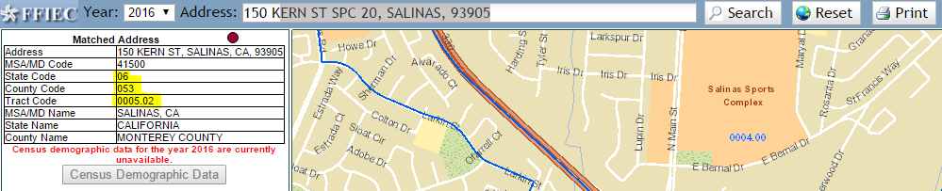

DWR Website
If you use the DWR website, the Census Tract number is located under the Disadvantaged Community Glock Group section. Enter the number in ServTraq in the following format: 60530005022 (omit the first 0)

http://webdev02.geiconsultants.com/saveourwaterrebates/
