Marketing & Outreach Custom Report

Background
Custom reports are a great tool to generate data for various purposes. This procedure will walk you through the process of extracting data on previously benefitted customers not currently benefitted for the current program year.

Step 1: Select Data Fields to Build Report
Under the Analytics tab, select Payment Assistance Custom Reports. Click on “Show Column Chooser” to gain access to the data output fields available. 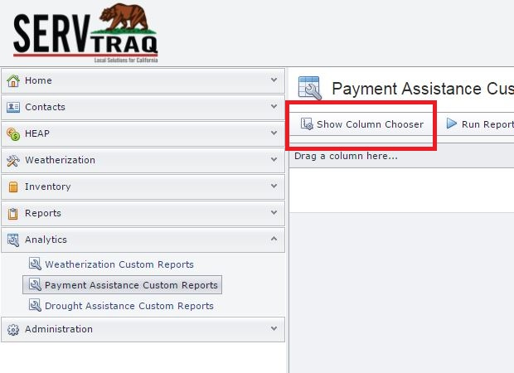
In the left hand box titled “Available Fields” select as many output fields as needed and click Add>. For this specific report the following output fields are recommended:
- Social Security Number
- First Name, Last Name
- Mailing Address, City, Zip Code
- Service Address, City, Zip Code
- Program Year
- Application Status
Next, select the payment assistance program years and click Add>. The program year selection is necessary to compare applicants served under one program year (i.e. FastTrack 2015) and not the other (i.e. FastTrack2016). 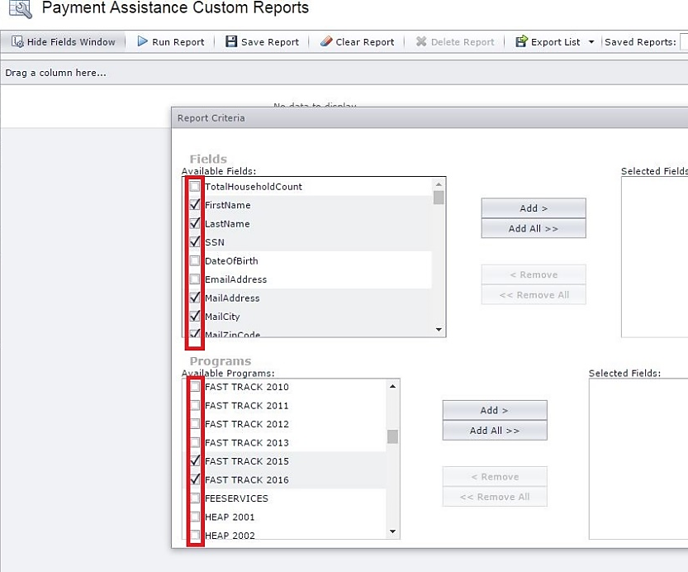
Once the selected output fields and programs have been added, click the “X” in the upper right corner to close the Report Criteria box.

Step 2: Extract the Data from ServTraq
Click the “Run Report” button to extract the data.
Optional step: We advise to save the custom report just in case ServTraq times out or doesn’t export properly during the next steps. To save click on the “Save Report” button on the ribbon.
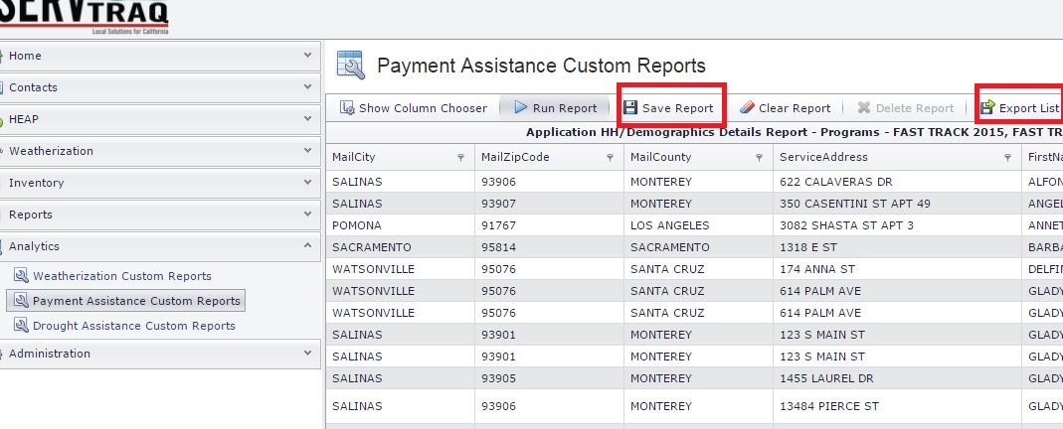
Place curser on the “Export List” drop down button and click “Export to CSV” format. Once it exports click “Enable Editing” and save the spreadsheet before going any further.

Step 3: Sort and Filter the Data
From the Excel Home tab, go to Editing>Sort and Filter and select Custom Sort from the available options. 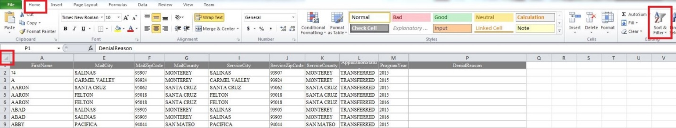Sort the data by Social Security Number from “Largest to Smallest”. Click the “Add Level” button and select “Program Year” and sort by “Largest to Smallest” and click OK.
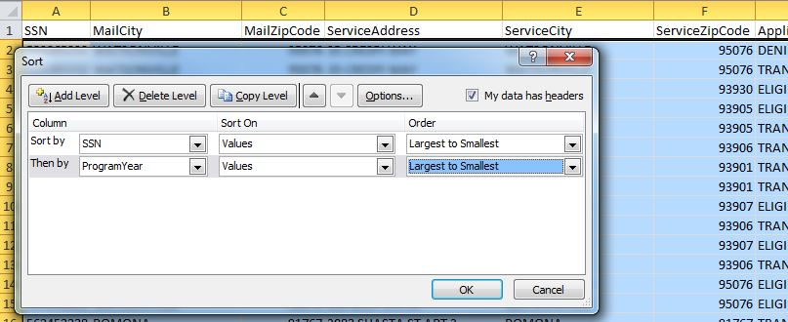

A “Sort Warning” may appear. Click “ok” to sort anything that looks like a number as a number.
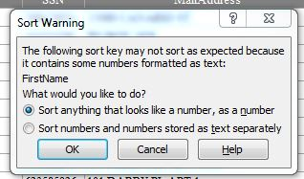

Step 4: Remove Duplicate Values
Go to the Data tab and click on the “Remove Duplicates” button. A menu will pop up with values for excel to check through for duplicates. Click “unselect all” and only checkmark the SSN box and click ok.

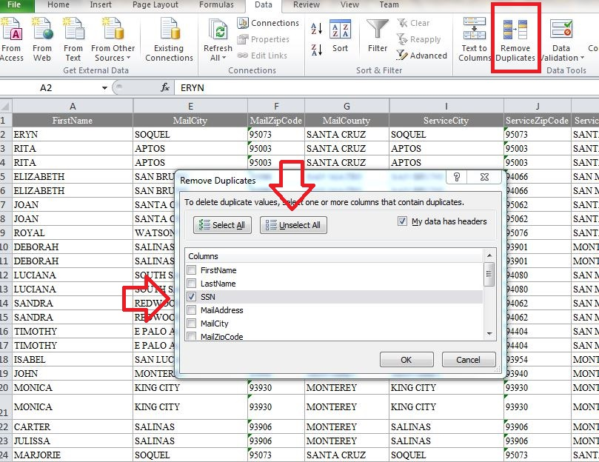

Step 5: Remove
Next, filter the Program Year column by “Smallest to Largest” and delete all 2016 Program Year records. Your list will now only have applicants benefitted in program year 2015, not assisted in Program Year 2016.
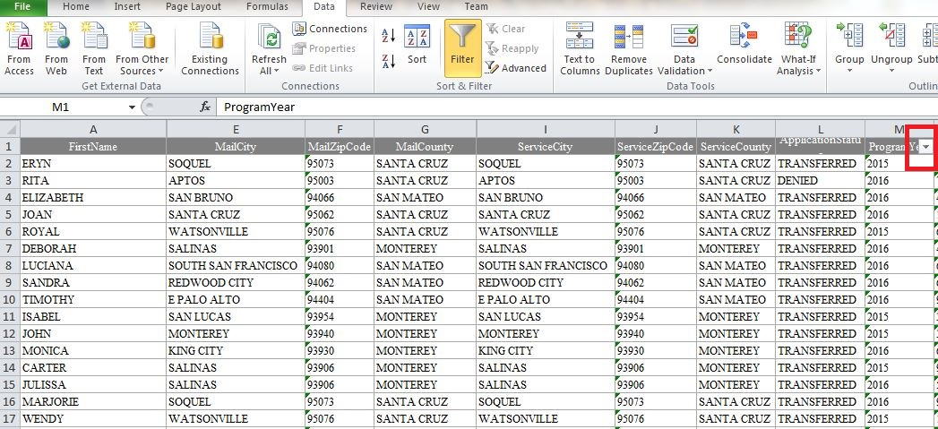

Additional Information

Excel Data Conversion
Excel provides different format types. In some cases, number columns may not be recognized as actual numbers. To convert column data to numbers, manually highlight the ENTIRE column and click on the little box that appears to the side of the column. Select “Convert to Numbers”. If the little box does not appear, you will need to double click inside one of the cells from that column, then click out of the cell. Finally reselect the entire column and it should appear.
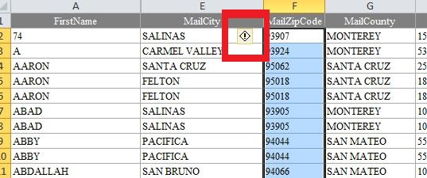

Additional Report Criteria
The most important step before running a Marketing and Outreach report is to identify the basic criteria necessary to create an accurate report. Below are additional options to consider:
Account Number – The Account Number field allows for a duplicate check on households assisted in different program years under different household members.
Denial Reason – The Denial Reason field allows for possible inclusion of certain customer denied for services which may now be eligible.
For example: Customers who were denied because of a “credit balance” who haven’t reapplied.

