Allocations by County

Background:
Payment Assistance (Program) allocations must be entered in ServTraq to make use of the built-in Payment Assistance Reports. The allocations must be set up by subprogram and by county otherwise there will be discrepancies between the Expenditure Progress by County and Expenditure Progress Summary report. Please note that even if you only serve one county the same process must be followed.
Requirements:
You must have Agency Administrator permissions enabled.
Procedure:
From the Administration tab, click on the Agency Details field. When the Edit Agency Details window pops up, scroll down to contracts and click on the contract number in question.
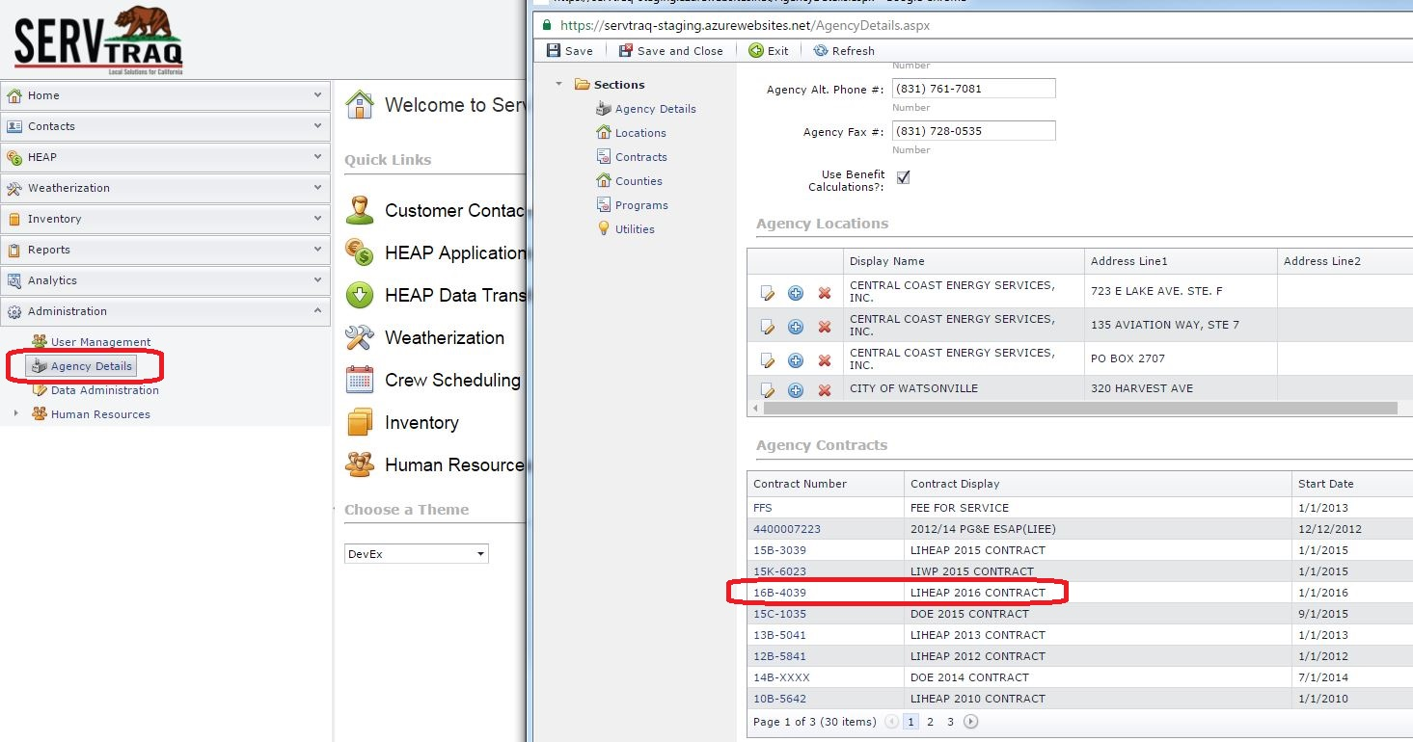
After you have opened the Contract, scroll down to the Subprograms section and click on the edit Icon.
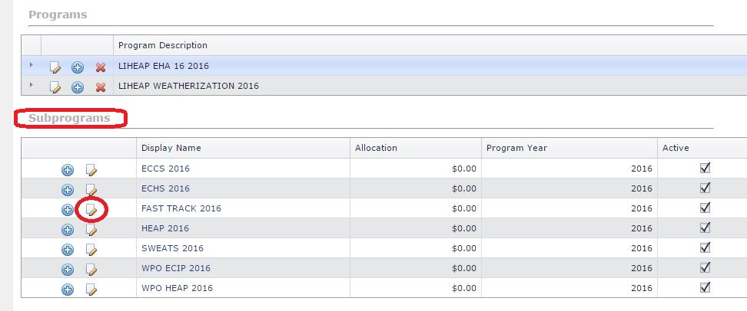
The “Edit Subprogram” window will pop up, scroll down until you see the “Service Counties” section. Click the Edit button for your county or counties and enter the appropriate amount in the Allocation field.
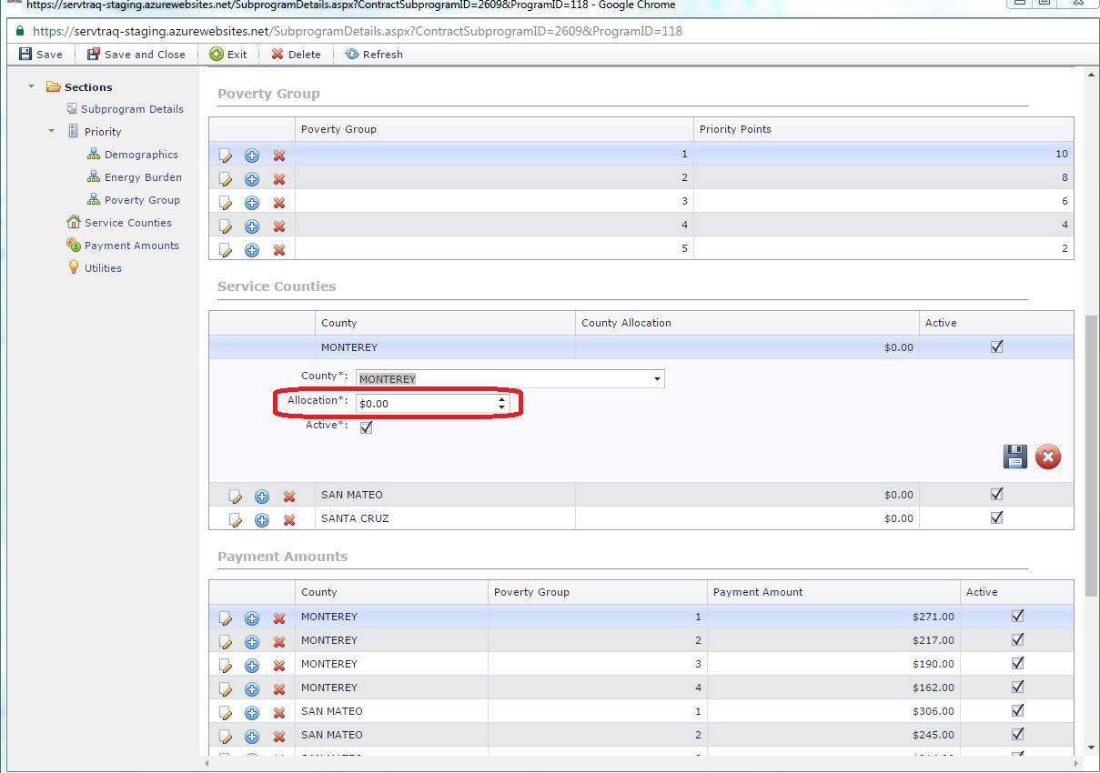
Make sure a check mark is in the “Active” box and click the floppy disk icon to save the change. Lastly Click Save and Close on the top ribbon to finish and exit.

