UA Intake Appointment Scheduling

This allows scheduling of intake appointments for existing customers. If the customer is not already in ServTraq, they will need to be added before an appointment can be scheduled.
Appointments are scheduled using Employees as resources. The employee must have the Intake Appointment Resource? Box checked on their employee record in order to show up as an available resource eon the intake appointment schedule.
The link for the Intake Appointment Schedule in under the HEAP section at the bottom:
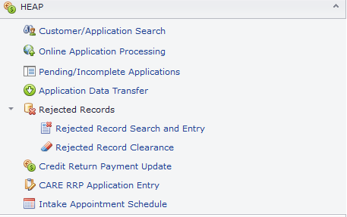
The schedule page consists of a list of existing customers and a calendar component. The calendar can be viewed by day, week, month, timeline, or agenda. Given the number of appointments that may exist in a week, the most useful view is likely to be the day view for a single resource. That is the default view. The number of resources displayed can be changed using the + and – buttons to the left of the resource dropdown.
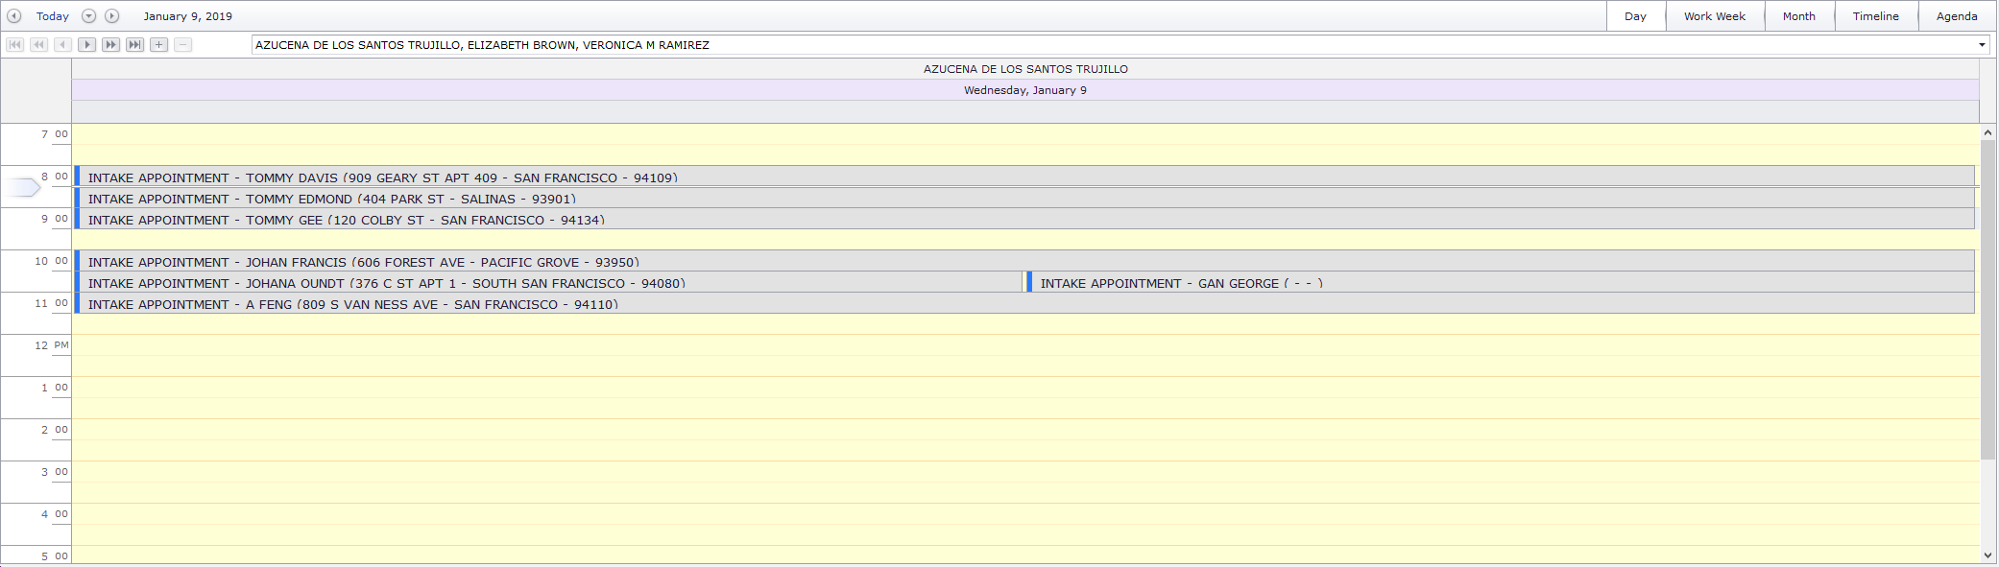

The list of customers loads all existing customers be default. It can be filtered using the text fields below the column header for each column:
The filter will be applied to the corresponding automatically once the user stops typing.
The list can also be filtered on a global level by using the search box in the upper right-hand corner of the list:
The only caveat to this is for searching by SSN. Searching by SSN only works in the text field in the SSN column. The SSN must be typed in completely and match exactly to return any results. This is due to the custom encryption applied to the SSN field in the database.
Once a customer is located, the appointment can be scheduled by selecting the date/time in the calendar and clicking the icon in the list corresponding to the customer the user wants to schedule.
The following form opens:
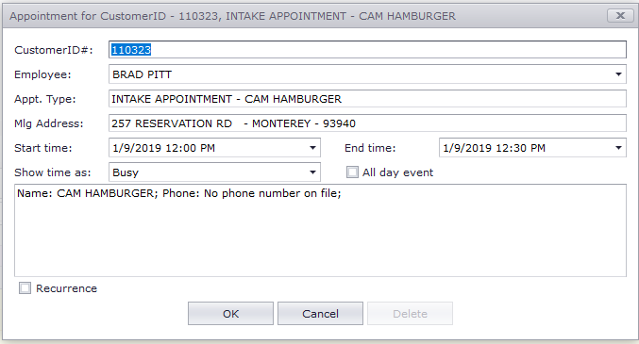
Once the appointment is added, a contact record is created in the customer file.
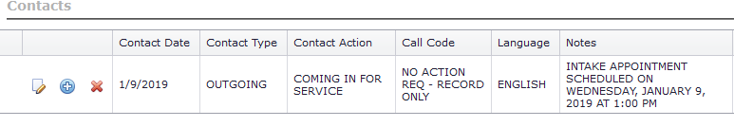
In order for a contact record to be created, the agency must have a Contact Action of “COMING IN FOR SERVICE” and a Call Code of “NA”.

A history of customer intake appointments is available on the customer record:
