Fuel Logs In the ServTraq APP

Step 1. Log into the ServTraq app

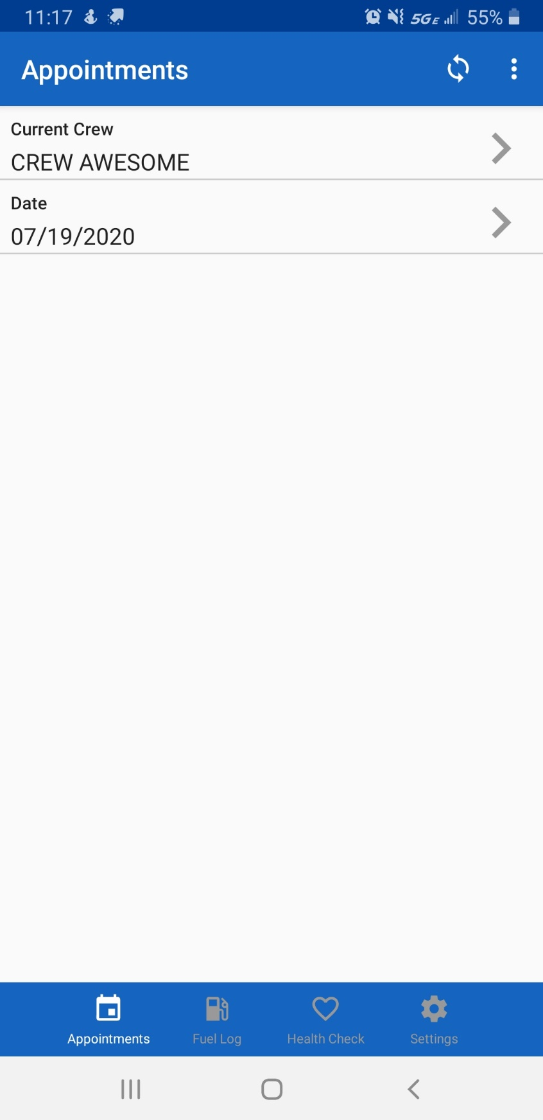

Step 2. Click on the “Fuel Log” button on the bottom of the screen

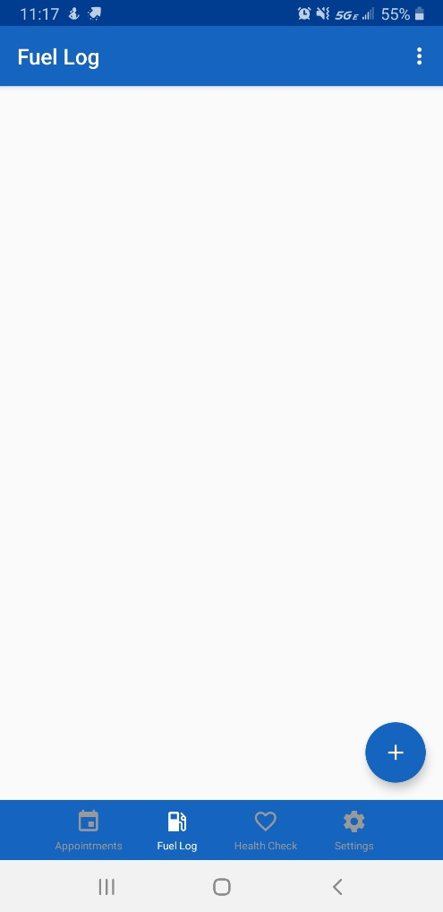

Step 3. This will take you to the fuel log page. From here tap the plus icon to add a new entry

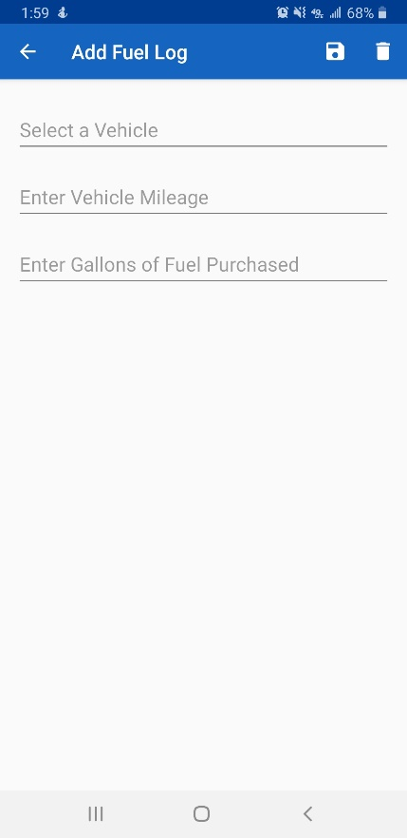

Step 4. Select the vehicle, enter the mileage and gallons of fuel purchased, click the floppy disk icon to save your entry

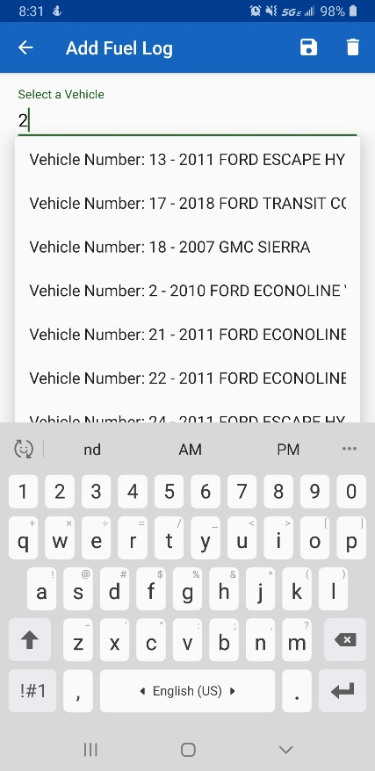

As you start typing the name of your vehicle, ServTraq will attempt to predict the name. Select the correct one

The vehicle list on the Desk top, contains all the vehicles that collect fuel logs. It is from this list that the fuel log allows you to select your vehicle. Click on the description to see details and logs

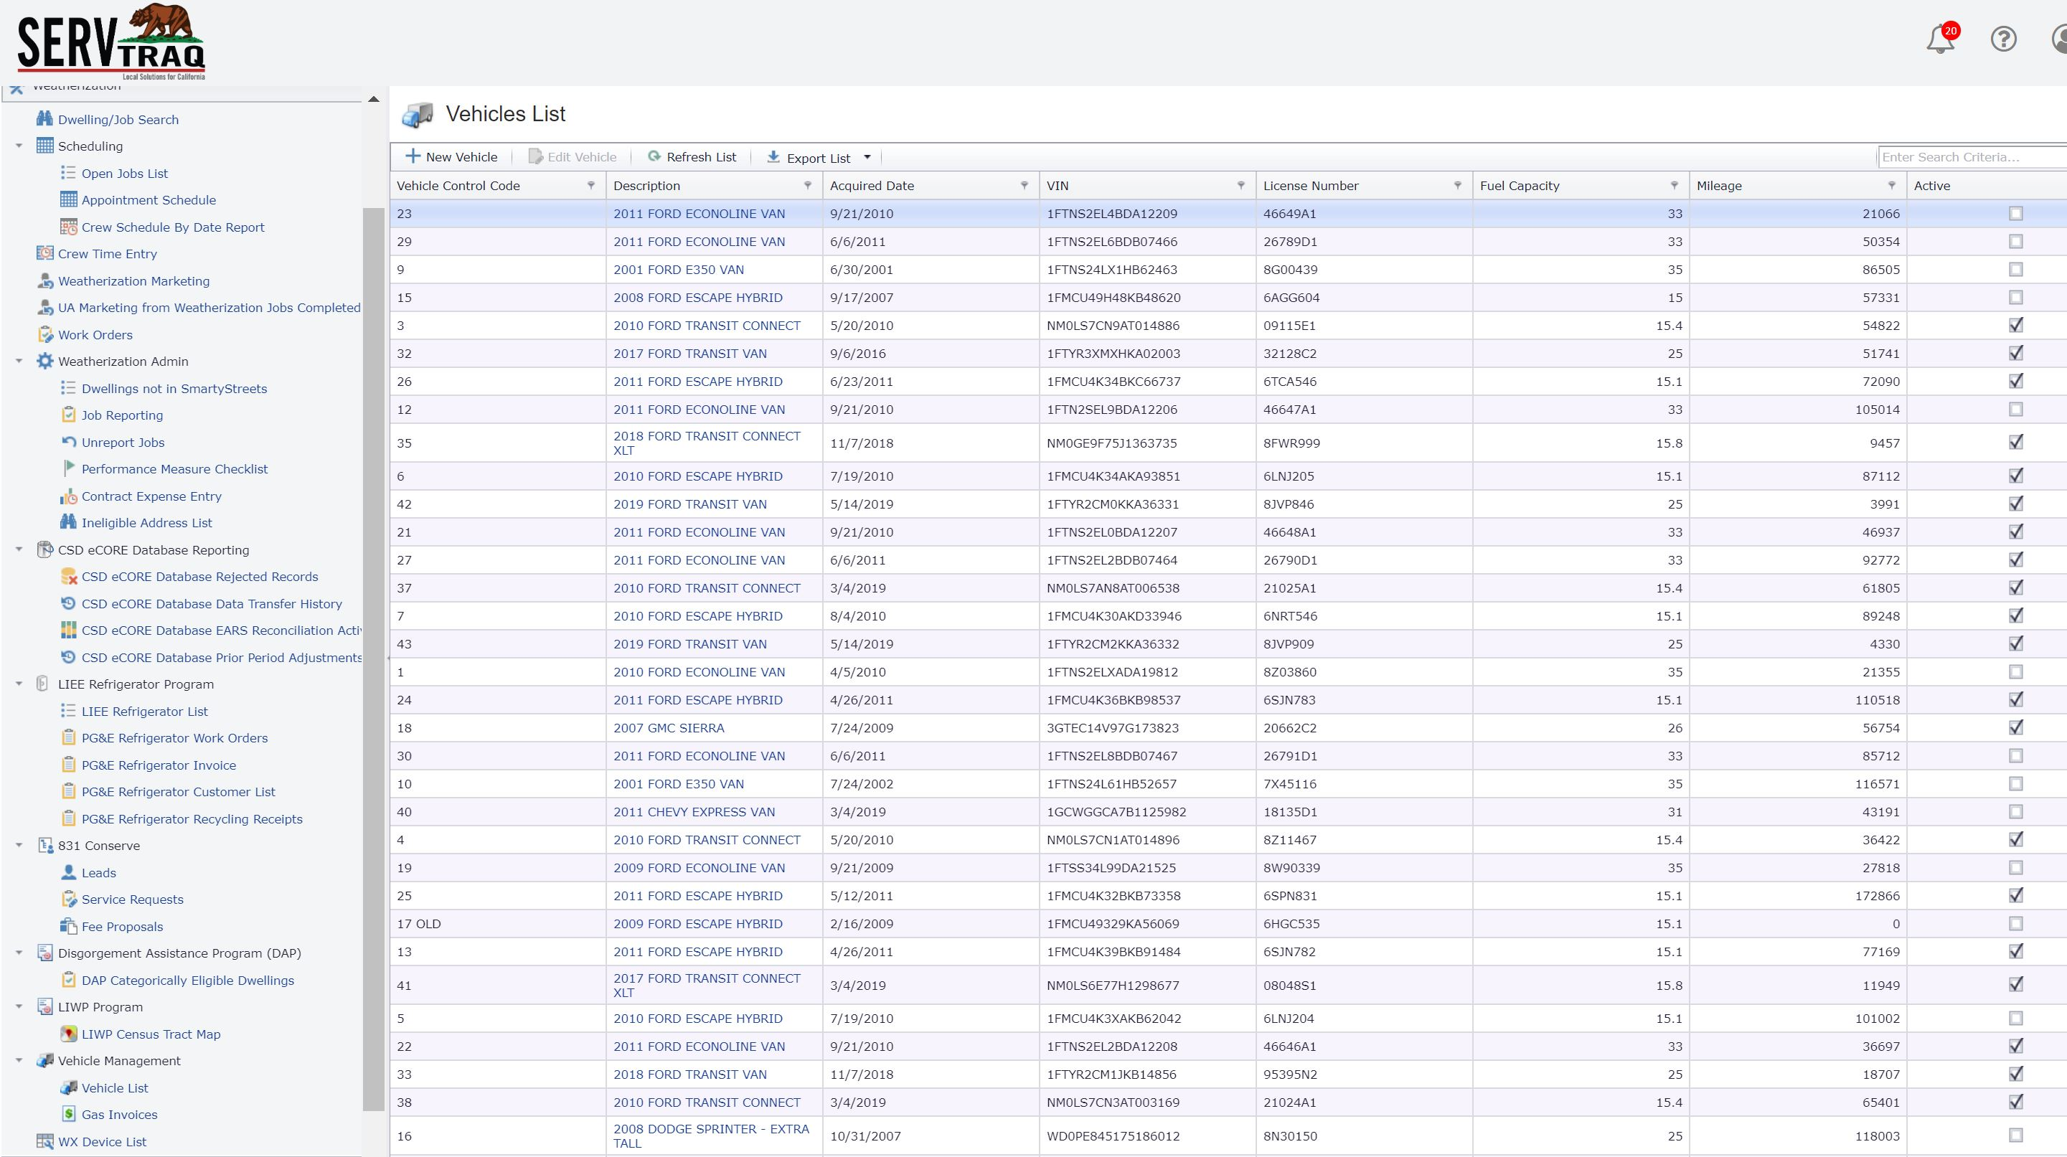

When agents sync up their apps, the fuel logs are applied to the individual vehicle records

